**Sprint - 1**

**Working With The Dataset (Loading The Dataset)**

|  |  |
| --- | --- |
| Date | 20-10-2022 |
| Team Id | PNT2022TMID39865 |
| Project Name | Estimate The Crop Yield Using Data Analytics |

* View And Analyze The Data.
* First Upload the Data In IBM Cognos After Understanding Them. Cognos Most Supportive Tool For This Task, It Can Connect Wide Variety Of Data, Stored In Variety Of Places.
* 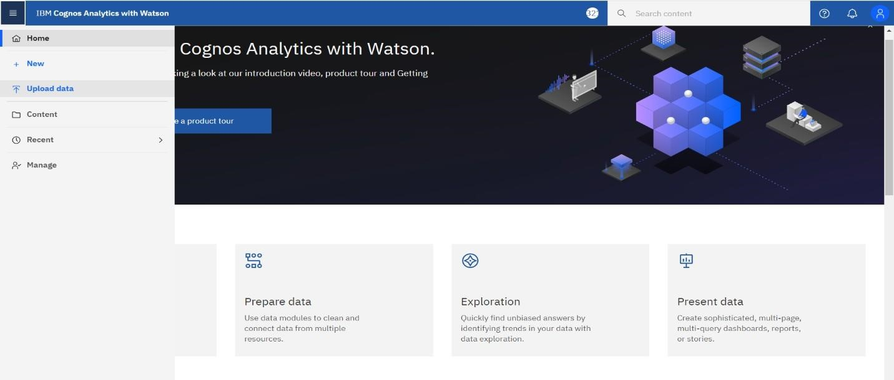The Might Be Stored In System Storage , Drive As Txt File, Csv File And Other Files , Or In Big Data , Relational Or Cube Database On Server In Enterprise

1. **Login Into Ibm Cognos**

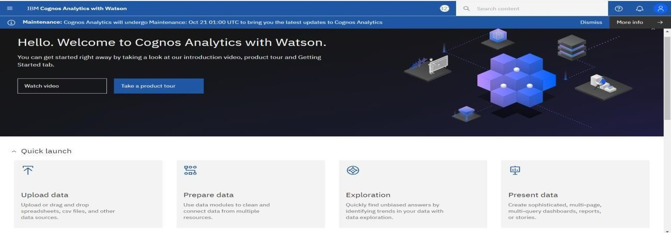

1. **Go To Menu, Click On ‘Upload Data’:**

1. **Select The Dataset:**

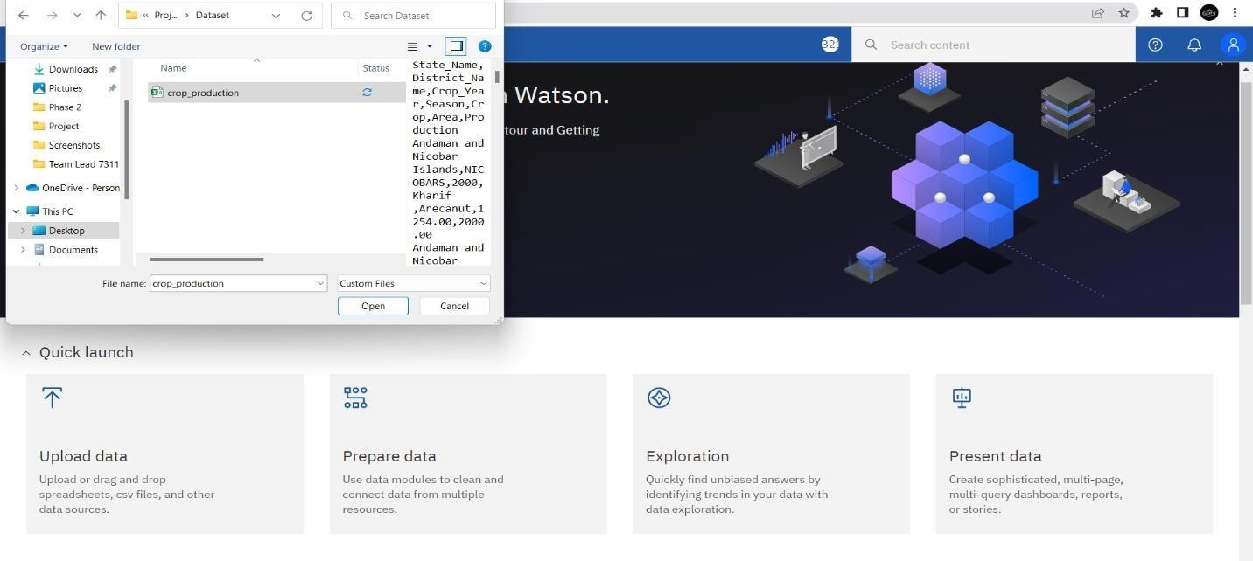

1. **Click On ‘Open’ and Wait Till The Dataset Is Uploaded:**

